# Backup Settings

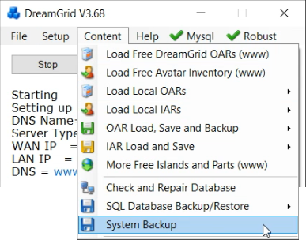

A manual backup uses a lot of disk space, but it backs up all critical files quickly and in a usable form. It will save the selected items in the AUTOBACKUP folder.   
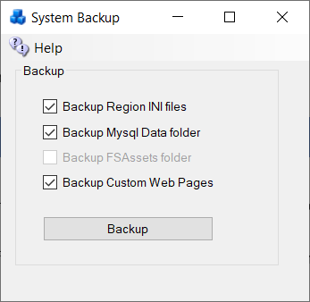  
  
Some of these boxes may be grayed out or uncheckable because the system has not installed that service.

## CheckBoxes

**Backup Region INI files** All files from Opensim\bin\Regions are copied. The useful ones are in the bin\Region\DosBoxName\Region\folder

**Backup MySQL\Data folder**: This folder holds the database. The rest of the folders in MySQL are just code or changeable settings that come in an update.

**Backup FSassets Folder**: If you are running the FSAssets system, this contains just the assets of the database. You still need to backup MySQL.

**Custom Web Pages**: This backs up two folders in bin\WifiPages-Custom and WifiPages-Custom in case you have made changes.

## Backup Strategies

There are multiple kinds of backups. Backups are at the region level, or at the grid level, which includes regions.  Also remember there are always two or more databases on a grid: the grid's robust database, and the regions Opensim database. There can be more than one Opensim database, as a grid can consists of more than one machine.

### Region Level OAR

OARs can be created on the fly - look in Content Save Oars and you can do them all with one click.  You can also set up OARS to be created on a schedule. - 24 hours is an excellent choice.

### Grid level IAR

IARS are more difficult and are more time consuming, as you need the password.   But you should make them on occasion anyway.  Just in case. They take a long time and can lag a grid when running.  If you are on OsGrid or Metro, I HIGHLY RECOMMEND you get an IAR backup often!  I have at different times lost data at both these major grids.

### Grid level SQL

SQL backup is also slow, but very thorough. It saves outfits, logins, and usernames; everything but region UUID's and settings.  With this you can fix problems in MySQL that are known to develop.   This is sort of a monthly thing to do.

### UUID:

Keep a copy of your UUID, too. This is available in your Profile. If you must start over, at least your new avatars will have the same UUID and will own everything you created.